An evolutionary tree, called a phylogenetic tree, is shown below for chordates. You will use this tree to explore how phylogenetic trees are constructed.

Step 1: The six words to the right should be written vertically onto the six bars seen on the right of the image. (They are currently mixed up in order). The tallest bar means that all the animals listed share that characteristic. Shorter bars represent fewer animals that have that characteristic. Figure from Campbell Biology, Concepts and Connections, 7th edition.

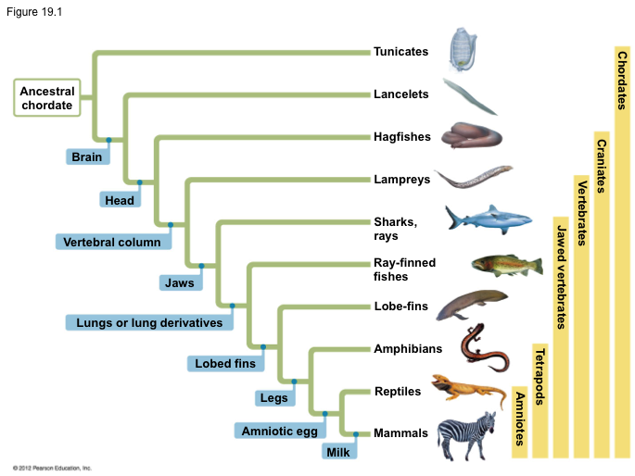

Step 2: Each branch point represents the common ancestor of all species that descended from it. The blue boxes represent characteristics, or homologies, shared by all descendants of this common ancestor. Fill in these blue boxes now with the list of nine words below:

jaws; head; lobed fins; brain; legs;
vertebral column; milk;
amniotic egg; lungs or lung derivatives;

Step 3: Read this passage and write “yes” or “no” in each box for whether each group has the characteristic or not.

A common ancestor led to the mammalian lineage. Two features of all mammals are hair and mammary glands. The most primitive group, the monotremes, are the egg-laying mammals. The other two groups of mammals, are born rather than hatched. These two groups, the marsupials and eutherians both possess a placenta, which provides nutrients to the embryo from the mother’s blood during development in the uterus. Eutherians diverged as a distinct lineage from marsupials to give rise to the majority of mammals on earth today. They have long gestation periods inside the uterus.

Trait | Monotreme | Marsupial | Eutherian
Hair? | yes | yes | yes
Mammary Glands? | yes | yes | yes
Placenta? | no | yes | yes
Long gestation? | no | no | yes

Step 4: Construct a phylogenetic tree for mammals. Don’t forget to add shared characteristics to your tree.
