Oceanic Action Project
Due: _________________

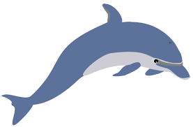

During this project your objective is to identify an oceanic issue you want to study. This can be a part of (but is not limited to this list):

-Over fishing (there are many animals that can be studied: sea turtles, dolphins, crabs, tuna, etc.)
-Coral reef destruction
-Desalination (extracting freshwater from the ocean for human consumption)
-Pollution (trash, chemicals, etc.)
-Climate change (rising sea levels)
-Shore habitat destruction

You will work with ONE other person (choose wisely) to complete this project. You will have time in class to research your topic, identify a main problem, and develop an action plan for a solution to this problem. You will share your presentation with the class through a 10 minute presentation. This can look like a poster, a PSA (Public Service Announcement) video, a prezi or powerpoint presentation.

Your action plan will be a one page well developed written document. Included will be:
-Location (map included)
-Problem identified and explanation about why you feel this issue is important
-Causes
-Possible solutions
-Plan for action!

You will be graded on your completion and effort of this project. Rubric will be available on Monday.

