**Biology Lab! Name/ class period:**

**Directions:**

Every 10 minutes rotate to a new station. Work with your table groups to complete.

**Station 1: Integumentary Coloring**

Use colored pencils/ markers color in the layers and parts of the integumentary system.



**Station 2:** **Skeletal Scavenger Hunt**

In the envelope use the blank skeleton and match the bones to the correct anatomical location. Then label the skeleton below once you have checked your answers with Ms. Graham

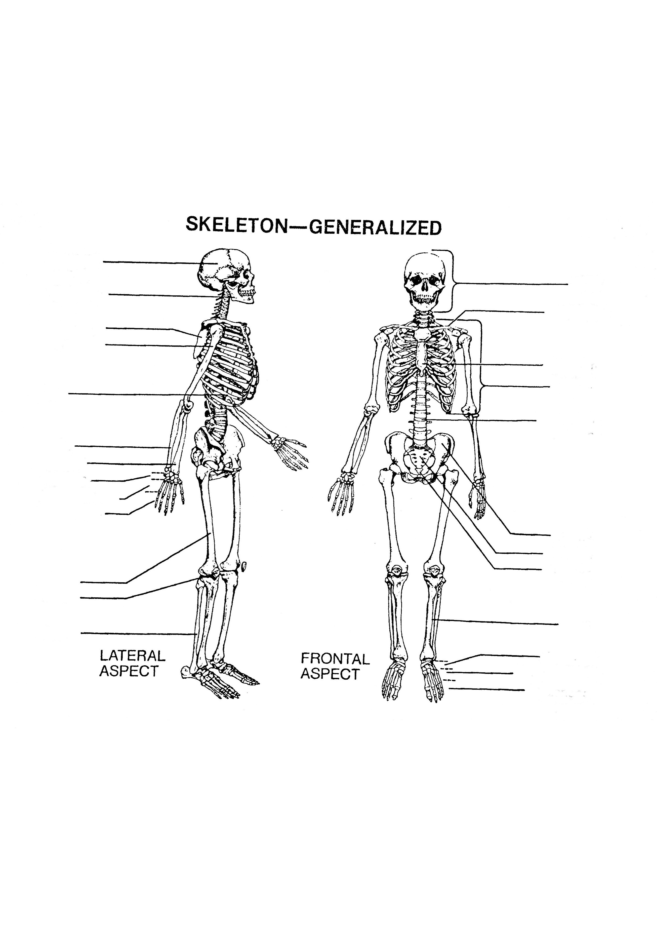

**Station 3: Rubber Egg**

Observe the “rubber egg”. You may touch it… but be GENTLE!

What do you notice?

Predict why the egg is the way it is?

Discuss why this related to the human body:

**Stations 4: Human System Outline**

On your piece of butcher paper elect a volunteer to be traced. Draw the outline of the person and draw the location of the **skeletal, muscular, and integumentary systems.** Please use the textbook for reference. ** We will be continuing to fill these in as we learn more about the systems so please leave room for more! ☺

**Station 5: How do muscles work?**

Place your fingers along the angle of your jaw just in front of your ear and then clenching your teeth together.

Observations: What happened?

Wrap a strip of paper around your upper arm and mark the circumference of your arm on the paper. Clench your fist tightly and mark the new circumference on the paper.

Observe what happens to the circumference of the muscle.

Record your observations:

**Station 6: Effect of Fatigue on Muscle Action**

Grasp clothespin with the thumb and index finger while the other fingers are held out straight.

1. Count how many times you can open and close a clothes pin in 20 seconds. Record in Figure 2.

2. Repeat the squeezing nine more times and record results. Do not rest

between trials.

**Figure 2: Effect of Fatigue on muscle action**

|  |  |  |
| --- | --- | --- |
| **Trial** | **# of open/close in 20 seconds** | **9 More X's** |
| **1** | ---------------------------------------- | ---------------------------------------- |
| **2** | ---------------------------------------- | ---------------------------------------- |
| **3** | ---------------------------------------- | ---------------------------------------- |
| **4** | ---------------------------------------- | ---------------------------------------- |
| **5** | ---------------------------------------- | ---------------------------------------- |
| **6** | ---------------------------------------- | ---------------------------------------- |
| **7** | ---------------------------------------- | ---------------------------------------- |
| **8** | ---------------------------------------- | ---------------------------------------- |
| **9** | ---------------------------------------- | ---------------------------------------- |
| **10** | ---------------------------------------- | ---------------------------------------- |

 Make a graph on the next page on Figure 3.

**Figure 3: Graph of Effect of Fatigue on Muscle Action**

Title your graph. Label your X axis number of attempts and your Y axis number of open/close

